ARTIFICIAL NEURAL NETWORK CONTROLLED AUTONOMOUS MOBILE ROBOT FOR CARRIAGE & TRANSPORT

Sri Lingeswar
Final Year, Department of Electronics and Instrumentation Engineering, Easwari Engineering College, Ramapuram, Chennai.
Rajaram K
Final Year, Department of Electronics and Instrumentation Engineering, Easwari Engineering College, Ramapuram, Chennai.
K.U. Sriram
Final Year, Department of Electronics and Instrumentation Engineering, Easwari Engineering College, Ramapuram, Chennai.

Abstract:
The major problem experienced by warehouse mangers is labour (manpower). It is always easy if a machine can do the work of a human being more efficiently. It may reduce the human effort, time consumption, labour wage, and also fatal accidents. In order to eliminate all the drawbacks, a new system is proposed called as The Autonomous Mobile Robots which are designed with the basis of Automation (Artificial Intelligence that can function without human interference) for carriage and transport purposes. It does not require human interference. It exemplifies a flexible and agile automation. It’s a robot that can interpret and move through its environment without being directly overseen by a human operator. By utilizing sensors, cameras, integrated with the specific program, it can manoeuvre in the facility transporting materials.

Introduction:
When it comes to automation purposes in warehouses and huge industries, engineers are trying to understand how embracing different technologies might help to make the work done there more efficient, and profitable. One such technology currently in the spotlight is Autonomous Mobile Robots (AMRs).
The term autonomous mobile robots refer to any robot that can interpret and move through its environment without being directly overseen by a human operator. By utilizing on-board sensors, cameras, and maps, they move around the facility. AMRs can be used to perform a number of functions, from transporting materials and goods to facilitating an existing pick strategy.
The aim of the project is to design an Autonomous Mobile Robot which is used to carry and transport a certain amount of load inside a facility. (e.g.) warehouses, library, etc. The AMR will traverse through the facility moving to different destination points. This system eliminates the factor of obstacle collision by detecting dynamic disturbances through its sensor. The AMR working is primarily based upon an ANN (Artificial Neural Network) concept called Image Processing.
Feature extraction of destination object is one main process to be seen which can be achieved through: HSV for the colour conversion,
SIFT (scale invariant feature transform) algorithm, key point matching method. In other words, the AMR is based upon a colour-based object detection technique.
Fayaz Shahdib and friends published a paper on “Obstacle Detection and Object Size Measurement for Autonomous Mobile Robot using Sensor”. They have said that different types of sensors are often fused to acquire information which cannot be acquired by a single sensor. Sensor fusion is particularly applicable for mobile robots for object detection and navigation. The techniques that have been developed so far for detecting an obstacle are costly. Hence, they proposed a new technique which can detect an obstacle, judge its distance and measure the size of the obstacle using one camera and one ultrasonic sensor. The technique is cheap in terms of sensor cost and in terms of computational cost. An autonomous robot moves unsupervised. It obtains information of surrounding environments using its sensors and decides its course of action according to its programming without any external help. If the information provided is inaccurate or incomplete, it becomes hard for the robot to decide its next action. Sensor fusion allows a robot to perceive its surroundings like human beings. Different type of sensors work differently and they have their strengths and weaknesses. One sensor cannot provide all the necessary information. Sensor fusion combines the strength of different sensor to overcome the drawbacks of the other.

OBJECTIVE
To develop an autonomous mobile robot capable of carrying, transporting load and transmitting real time video signals to a base station with the following features:
- Gains and provides information about the environment.
- Ability to traverse in known and unknown environment.
- Increased Safety: AMRs can interpret and navigate around variable obstructions (such as people, lift trucks, etc.)
- Increased Flexibility: Instead of following hard-set paths, they create their own routes between locations within a facility.
Existing system and problem:
- The existing system is based on the colour joint probability function that will look for the centroid of the colours and prepare a color edge co-occurrence histogram. Hence the accuracy of this system will less. This system can be able to operate only in indoor environment. The robot needs multiple software to process the path navigation. It is a very complex process.
- The old version which is the vision based obstacles avoidance (VBOA) mobile robot need servomotor for turning. This system used multiple type of sensor to detect the object. This type system are only used for obstacle avoidance operation only, the purpose of the project is to create an auto driver mode in cars. This system includes a reliable sensor and proximate sensor to get the obstacle inputs.
Limitations of the existing system
- It does not have carriage and transport operation whereas only has pick-and-drop ability.
- It is unable to operate in dark places.
- The sensors are too expensive.
- It implements only obstacle avoidance, whereas path planning is not done.
- It requires software for processing path navigation.
Proposed system:
In our proposed system, we have designed the robot in a simple and efficient way. We have used image processing as a tool to navigate the path and an ultrasonic sensor to detect the obstacles in the open environment. It has the ability to bear the load of 1Kg. In the robot path, if some dynamic obstacles are detected it will trigger an alarm instantly and wait for it to move away. Our motive is to create a low cost AMR; hence we used the raspberry pi as processor and 64GB memory to load the program to the robot. By this we can control the robot from remote access by using Wi-Fi and also we can mirror the image of robot camera in any smart devices. We can also change the program to our own convenient requirements via smart devices itself. In our application of a color-based object detection technique, we used the HSV for the color conversion, scale invariant feature transform (SIFT) for the feature extraction in the image and based on the key points matching, the object colour is identified.
STEPS INVOLVED:
- Destination Detection
- Moving towards destination.
- Detection of obstacle.
- Reaching the destination
By the system proposed by us, it is far more reliable and efficient than the previous and existing systems. This technique enables the mobile robot to recognize its destination spot easily and efficiently.
In this model, we are using artificial neural network concept as a platform to design the robot.
The navigation and collision avoidance is implemented by usage of Web cam and ultrasonic sensor for an autonomous mobile robot (AMR). The experimental setup is installed with an intelligent control system by applying the Image Processing technique of artificial neural network. This technique enables the mobile robot to recognize its destination spot easily and quickly.
In our model, we are using color detection in image processing to identify the exact place of destination towards which the object has to move. This AMR moves from the start point to the end point. The end point is nothing but the destination object. There will be multiple destination objects and they are distinguished by various colors.
HSV colour conversion is used for vision in places where adequate light is present and to distinguish the colour of the object more clearly. Scale invariant feature transform is used as it is the best algorithm for feature extraction. This method helps to acquire the “COLOUR” property of the destination object more effectively. Through key point matching technique, the colours are matched with the predefined profile and reliable results are produced.
This robot has a raspberry pi processor 3 Model B+ so, we can connect the robot to any smart devices via remote access (like Wi-Fi) and the application that helps this is the VNC viewer that is compatible in all smart devices.
Python language is used to code the AMR. The robot finds its application mostly everywhere. For example, in paper industries, huge load of bundles are delivered by trucks from places to places, library, warehouses, etc.

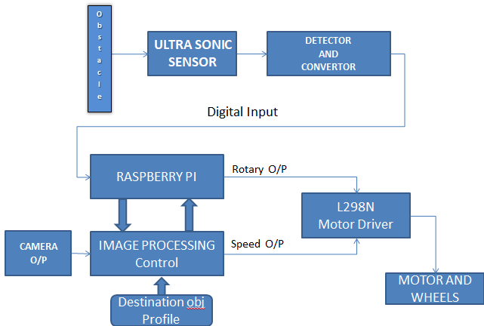
Block Diagram of AMR

Our mobile robot consists of a camera that always scans for the destination which are nothing but differently coloured objects, using Image Processing Technique.
The mobile robot is programmed to manoeuvre towards the destination. If there are multiple destinations, the program indicates the order in which they should be met.
The front edge of the AMR also consists of a Ultrasonic sensor to detect dynamic disturbances.
If it detects any dynamic obstacle, the ultrasonic sensors output is given to the raspberry pi controller which in turn stops the AMR from collision.
In case of dynamic disturbances such as human, it is programmed to stop and give a buzzer or alarm sound, to indicate the detection of obstacle.
After the dynamic disturbance is removed, the buzzer stops and the camera again begins to scan for the destination object and moves towards it.
The camera view of scanning can be viewed in the associated devices such as mobile phones, tablets or even laptops.
This camera view videos are recorded and stored for future logging purposes.
The mobile robot consists of a platform on the top to bear the load.

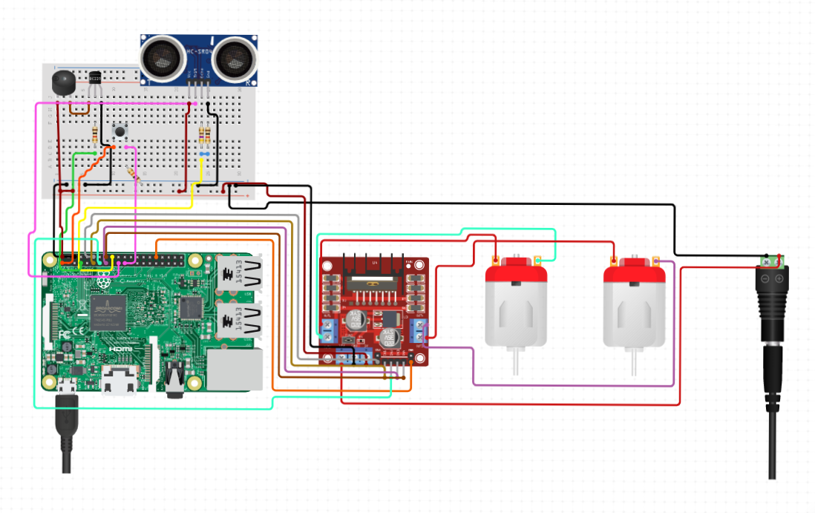
Circuit Diagram of AMR

Python language is used for coding and Raspberry PI as the controller that will be embedded in the mobile robot.
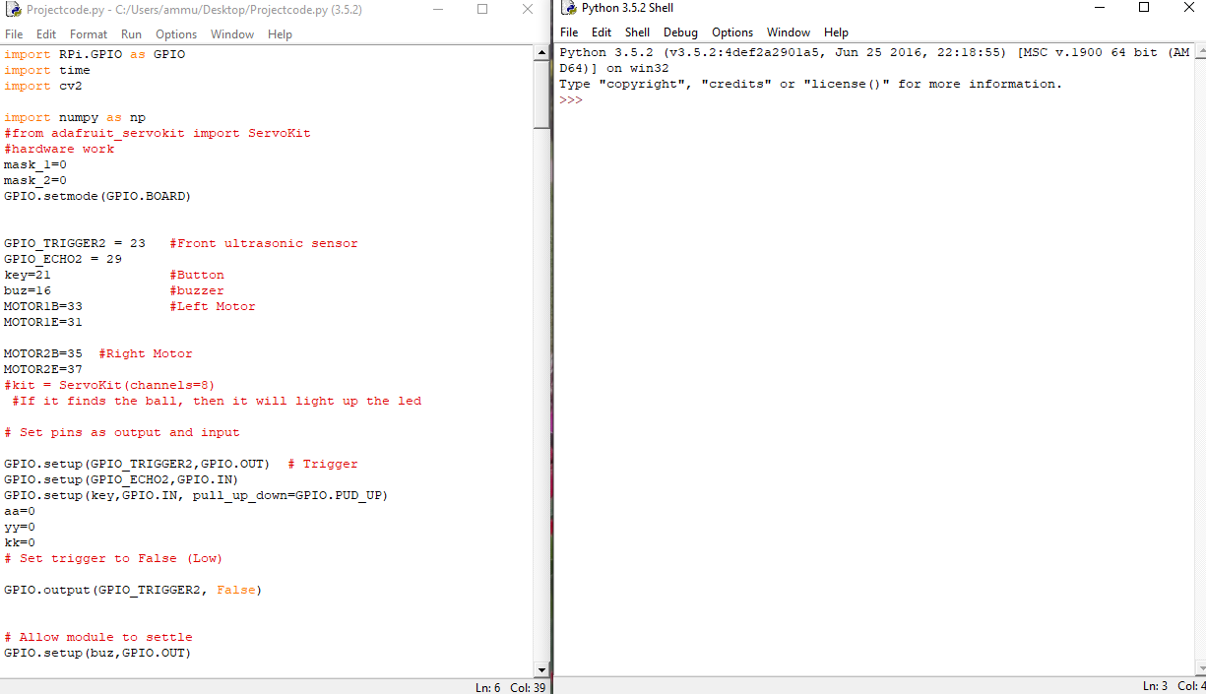

VNC Viewer: Virtual Network Computing (VNC) is a graphical desktop-sharing system that uses the Remote Frame Buffer protocol (RFB) to remotely control another computer (Raspberry Pi).

Point Feature Matching (PFM)
- In image processing, point feature matching is an effective method to detect a specified target in a clustered scene. This method detects single object rather than multiple objects.
- In our model, PFM is used to detect the DISTINCT destination object from the environment.
SIFT (Scale Invariant Feature Transform)
Key Point Matching Method
- SIFT, or Scale Invariant Feature Transform, is a feature detection algorithm in Computer Vision.
- SIFT helps locate the local features in an image, commonly known as the ‘key points‘ of the image.
- In our model, COLOUR is considered as the primary key point.
- These key points are scale & rotation invariant that can be used for various computer vision applications, like image matching, object detection, scene detection, etc.
- Now, the key points extracted from our image (for eg – colour, height, width) are compared with the predefined values.
- The comparison results are then used as inputs to the program for the detection, tracking and obstacle avoidance process.

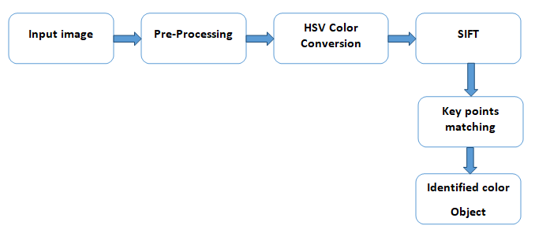
ANN Technique
Result:
Operation of a freely programmable kinematic device that performs services in structured and unstructured environment.
The robot detects the coloured ball and starts to move near it. If any dynamic obstacle distracts its path the robot stops moving and trigger the buzzer to clear the obstacle.
Once the obstacle moves it starts moving to the destination point A. After reaching the point A, the push button is clicked to trigger the robot on searching the next colour object.
ADVANTAGES that distinguish it from existing system.
- Better accuracy in segmentation under various illuminations
- Less time-consuming process
- It is less sensitive to background noise

Conclusion:
Our proposed system exhibits efficient operation of a freely programmable kinematic device that performs services in structured, unstructured, known and unknown environment. It has better accuracy in segmentation under various illuminations. It is mainly a less time-consuming process. It is less sensitive to background noise.
The system is also validated with an algorithm to detect destination objects or dynamic disturbances. It moves towards destination and stops when obstructed by dynamic obstacles.

Future work:
The future applications of AMR in the warehouse are extensive. The concepts of drone delivery, including flying drones and autonomous trucks, will become a more significant player in the AMR space. More companies will begin to explore the use of driverless trucks and flying drones for delivery, especially last-mile delivery.
The opportunities for efficiency and productivity gains through AMR technology will continue to grow in value and scope. Supply chain managers need to start thinking about how to put the power of robotics to work in their facilities to reduce costs and decrease order cycle times. Such technology will demand best-of-breed warehouse management and execution systems (WMS and WES), as well as full integration between all supply chain systems.
References:
- [1] Gurjashan Singh Pannu, Mohammad Dawud Ansari, Pritha Gupta. Design and Implementation of Autonomous Car using Raspberry Pi. International Journal of Computer Applications (0975 – 8887) Volume 113 – No. 9, March 2015.
- [2] Ayush Wattal, Ashutosh Ojha, Manoj Kumar. Obstacle Detection for Visually Impaired Using Raspberry Pi and Ultrasonic Sensors. National Conference on Product Design (NCPD 2016), July 2016.
- [3] Mr. T. P. Kausalya Nandan, , S. N. Anvesh Kumar, M. Bhargava, P. Chandrakanth, M. Sairani. Controlling Obstacle Avoiding And Live Streaming Robot Using Chronos Watch. International Journal of Engineering Innovation & Research Volume 5, Issue 2, ISSN: 2277 – 5668.
- [4] Xiaodong Miao, Shunming Li & Huan Shen, On-Board lane detection system for intelligent vehicle based on monocular vision, International Journal on Smart Sensing and Intelligent Systems, vol. 5, no. 4, December 2012, pp. 957-972.
- [5] A. Bar Hillel, R. Lerner, D. Levi, & G. Raz. Recent progress in road and lane detection: a survey. Machine Vision and Applications, Feb. 2012, pp. 727–745
[6] Narathip Thongpan, & Mahasak Ketcham, The State of the Art in Development a Lane Detection for Embedded Systems Design, Conference on Advanced Computational Technologies & Creative Media (ICACTCM’2014) Aug. 14-15, 2014.

